What is an FTC? What does it do?
Full Trash Capture (FTC) devices are trash screen devices installed inside stormwater drain inlets and catch basins designed to stop trash from further discharging into the storm drainage system. Stormwater drain inlets are the entry points for most stormwater runoff into the City’s storm drainage system, which is a series of pipes that directs the water directly to San Francisco Bay, usually without any intervening treatment or means to remove any pollutants. Stormwater drain inlets exist in a variety of shapes and sizes, such as in these photos of some common types.
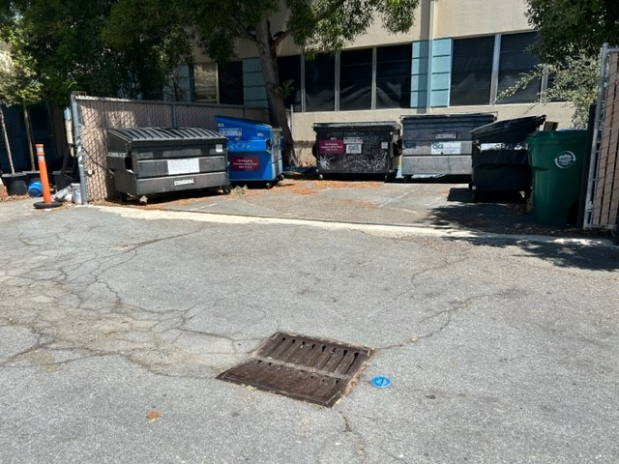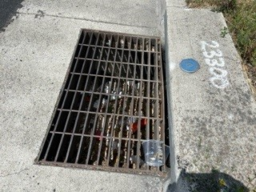

There are a variety of FTC types and sizes designed to accommodate the differing geometries and sizes of existing stormwater drain inlets and the associated catch basins below the inlets. Some FTC devices intercept the trash and debris before it falls into the catch basin (or pipes) that are below the inlet (the hanging-basket drop inlet model and the false-bottom “Top Hat” model types, for instance), while others block the outflow pipe at the bottom of the catch basin, the “pipe screen” models.
The State of California’s Water Resources Control Board has certified a number of make and model types of storm drainage trash capture devices that meet their specific criteria for a Full Trash Capture (FTC) device. The full list of the State’s Certified FTC devices (and their manufacturers) is found here:
https://www.casqa.org/resources/water-quality-priorities/trash/certified-trash-full-capture-systems-available-to-the-public
https://www.waterboards.ca.gov/water_issues/programs/stormwater/docs/trash_implementation/2024/full-cptre-for-public.pdf
Please see the full printed list of these manufacturers and their devices attached and/or below.
FTC Device Examples Include, but are not limited to:
An Oldcastle Manufacturing Drop Inlet style FloGard device https://oldcastleinfrastructure.com/brands/flogard/
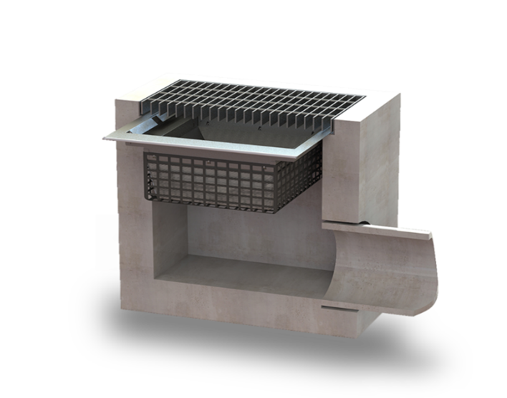

A R.E.M. false-bottom “Top Hat” model … https://remfilters.com/triton-full-trash-capture/
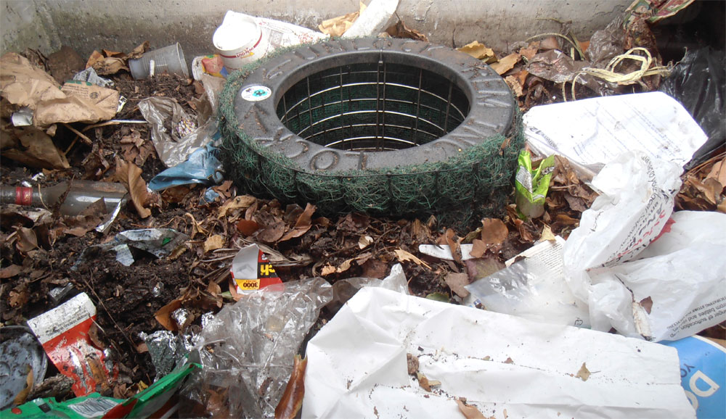
A S.W.I.M.S. connector pipe screen model … https://swimsclean.com/trash-capture/trash-capture-device-options/
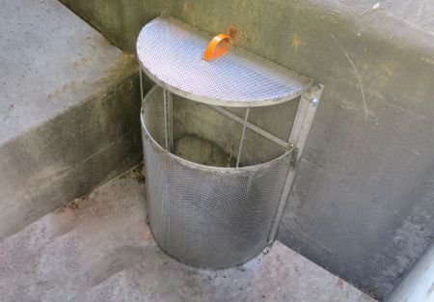

Since the various types and sizes of stormwater drainage inlets and/or catch basins/pipes below the stormwater drainage inlets will require different types of FTC devices, property owners/managers will need to discuss their specific FTC-type needs with the device installer to chose an appropriate device type at the correct size.
Active FTC device manufacturers and installers in the San Francisco Bay Area include:
OLDCASTLE MANUFACTURING
https://oldcastleinfrastructure.com/brands/
Customer Service: (888) 965-3227
REVEL ENVIRONMENTAL MANUFACTURING (R.E.M.)
https://remfilters.com/triton-full-trash-capture/
REM Inc
960 B, Detroit Ave, Concord, CA 94518
(888) 526-4736
STORMWATER INSPECTION AND MAINTENANCE SERVICES (S.W.I.M.S.)
Brentwood, CA and Livermore, CA for Northern California services
https://swimsclean.com/
info@swimsclean.com
(866) 967-9467

Other on-line references and resources include:
California Stormwater Quality Association (CASQA) Certified Trash Full Capture Systems Available to the Public:
https://www.casqa.org/resources/water-quality-priorities/trash/certified-trash-full-capture-systems-available-to-the-public
California State Water Resources Control Board’s Stormwater Pollution Prevention Trash Implementation Program page:
https://www.waterboards.ca.gov/water_issues/programs/stormwater/trash_implementation.html
https://www.waterboards.ca.gov/water_issues/programs/stormwater/docs/trash_implementation/2024/full-cptre-for-public.pdf
City of Alameda Public Works Department Clean Water Program:
https://www.alamedaca.gov/Departments/Public-Works-Department/Clean-Water-Program#section-1

